**NAAN MUDHALVAN**

**MEDICAL INVENTORY**

**MANAGEMENT**

**ST. JOSEPH’S COLLEGE FOR**

**WOMEN TIRUPUR**

**III B.SC. COMPUTER SCIENCE**

**TEAM MEMBERS**

**SADANAPRIYA K – TEAM HEAD**

**MAHALAKSHMI M**

**PRIYADHARSHINI D**

**SHALINI M**

**Logging Into Smart Internz**

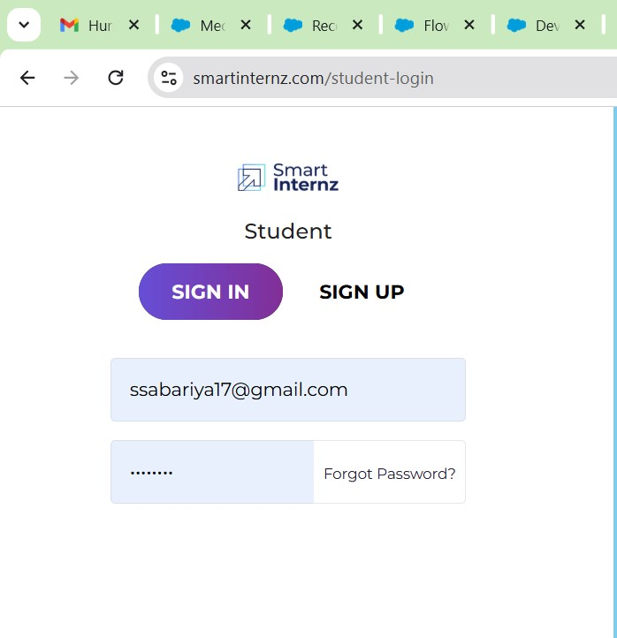

**Creating a Product Object:**

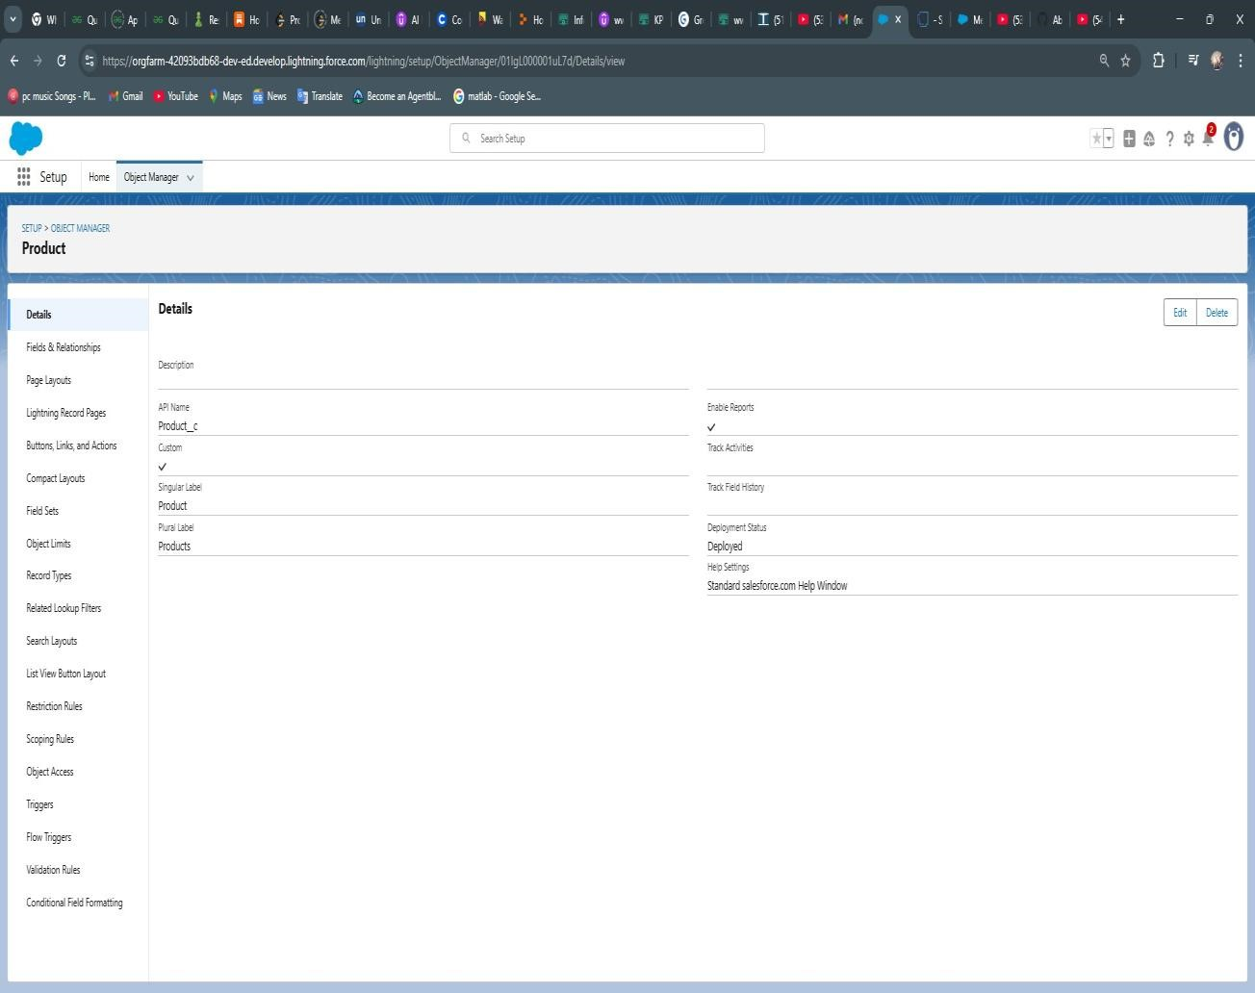

**Medical Inventory Management APP:**

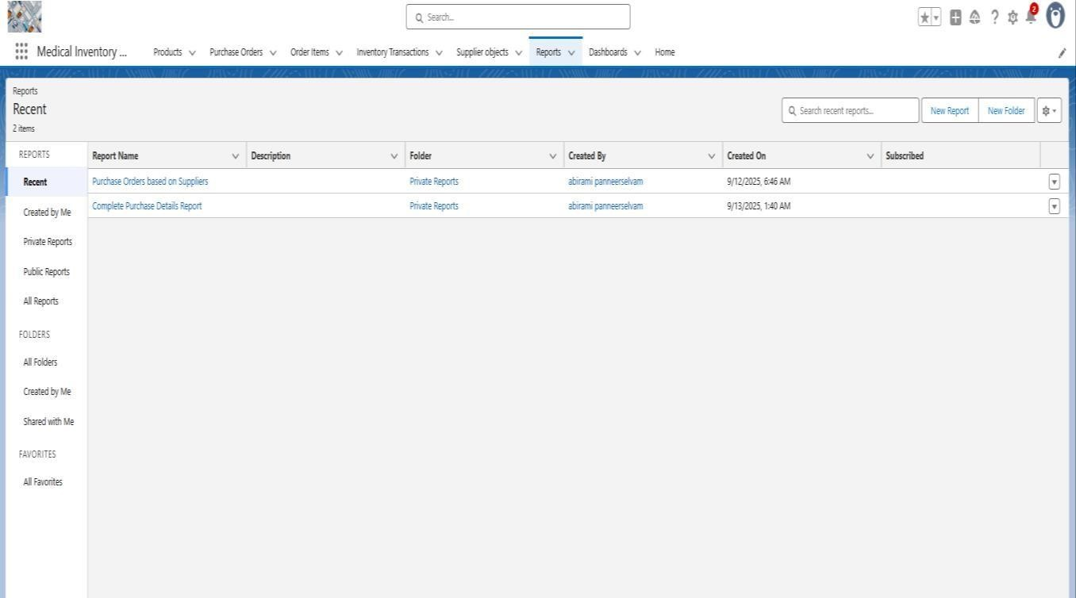

**Purchase order layout:**

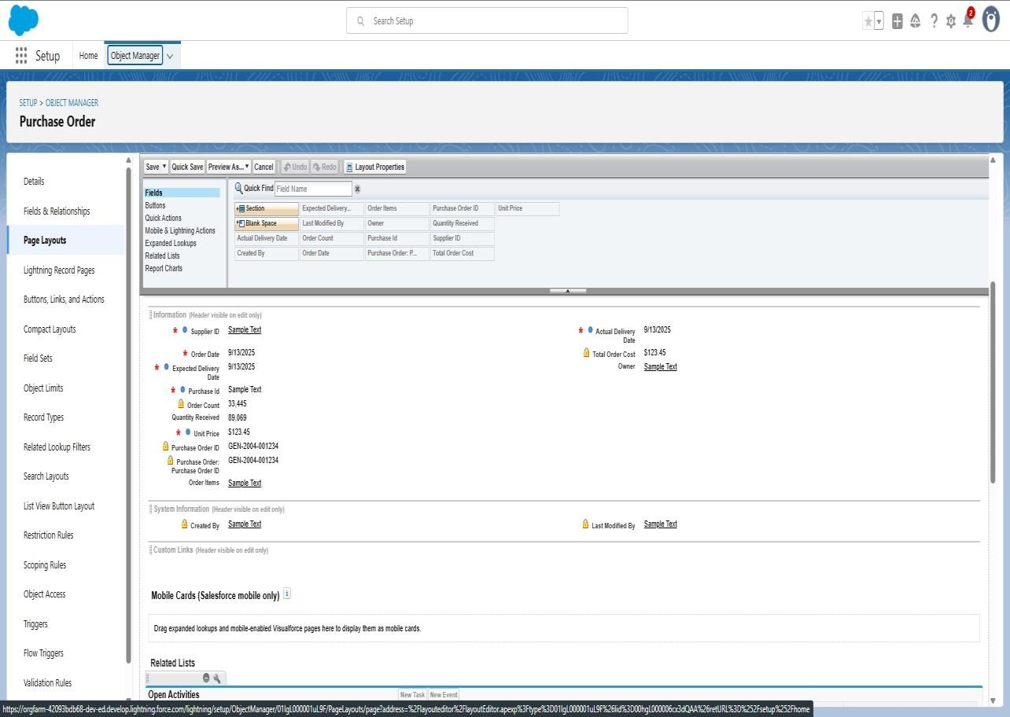

**Purchase order fields and relationship:**

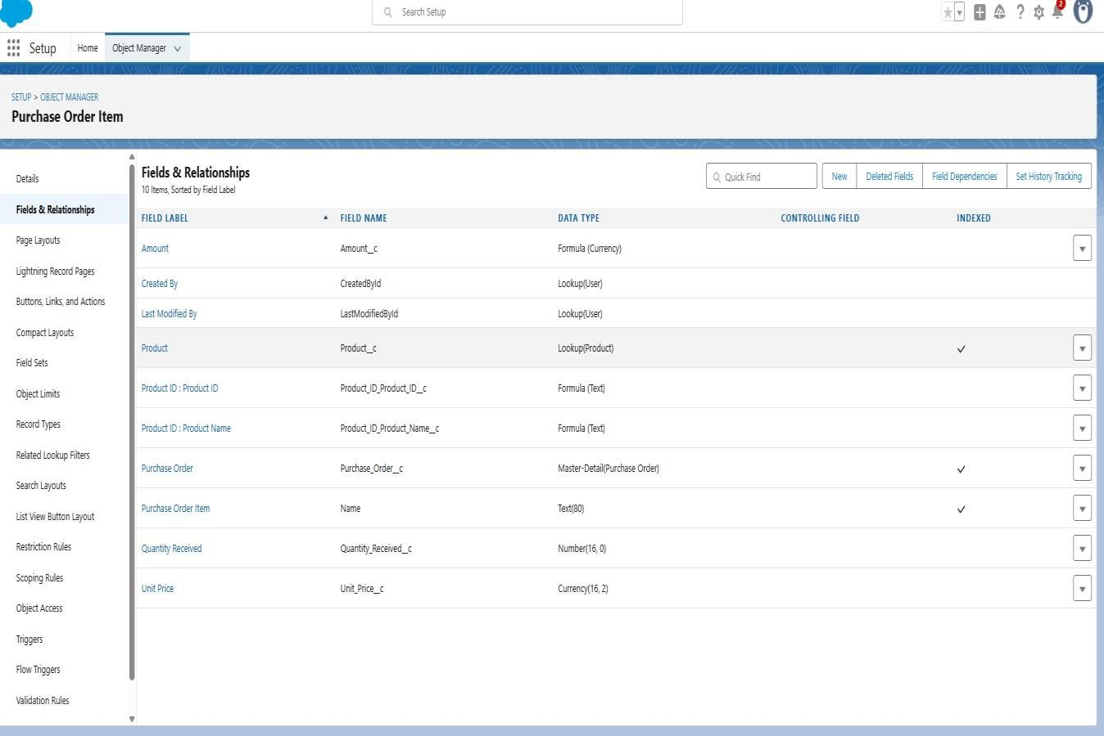

**Order Item fields and relationship:**

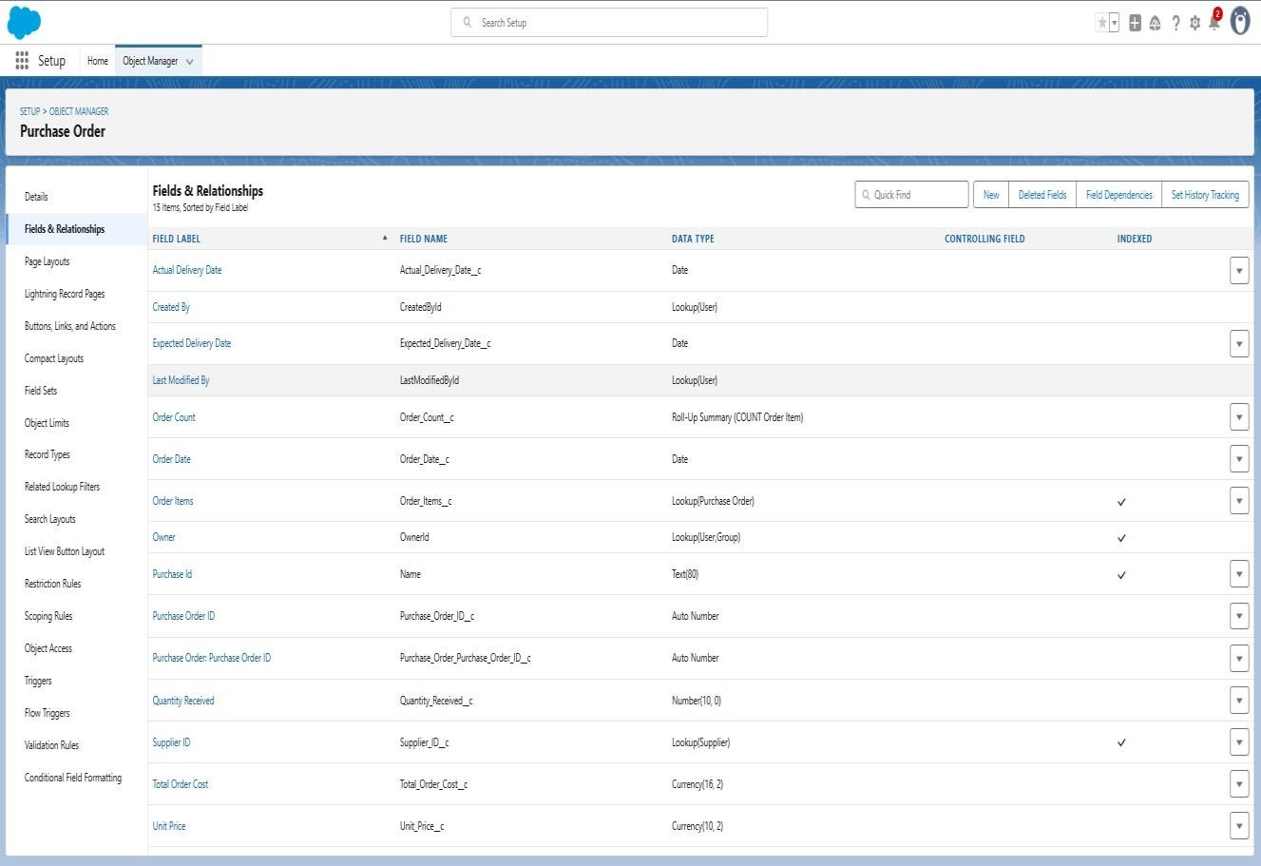

**Purchase Order Item Fields & Relationships:**

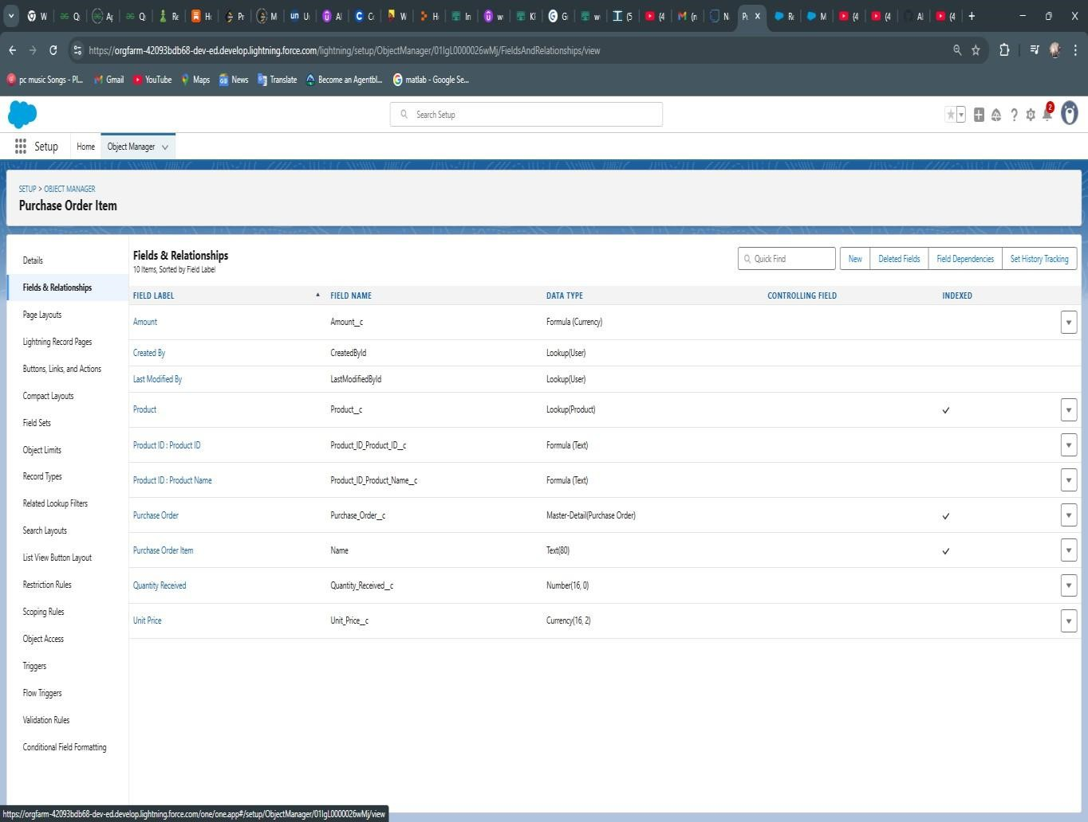

**Purchase Order Validation Rule:**

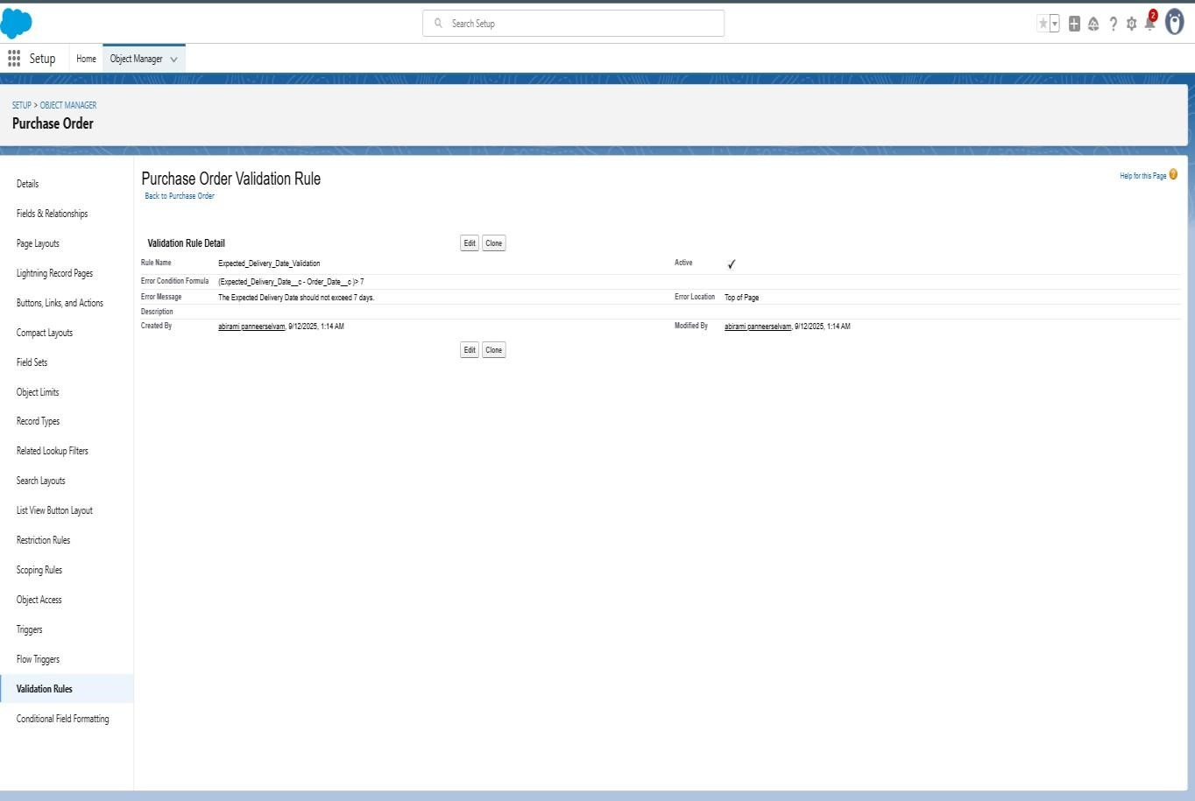

**Created an Inventory Manager Profile**

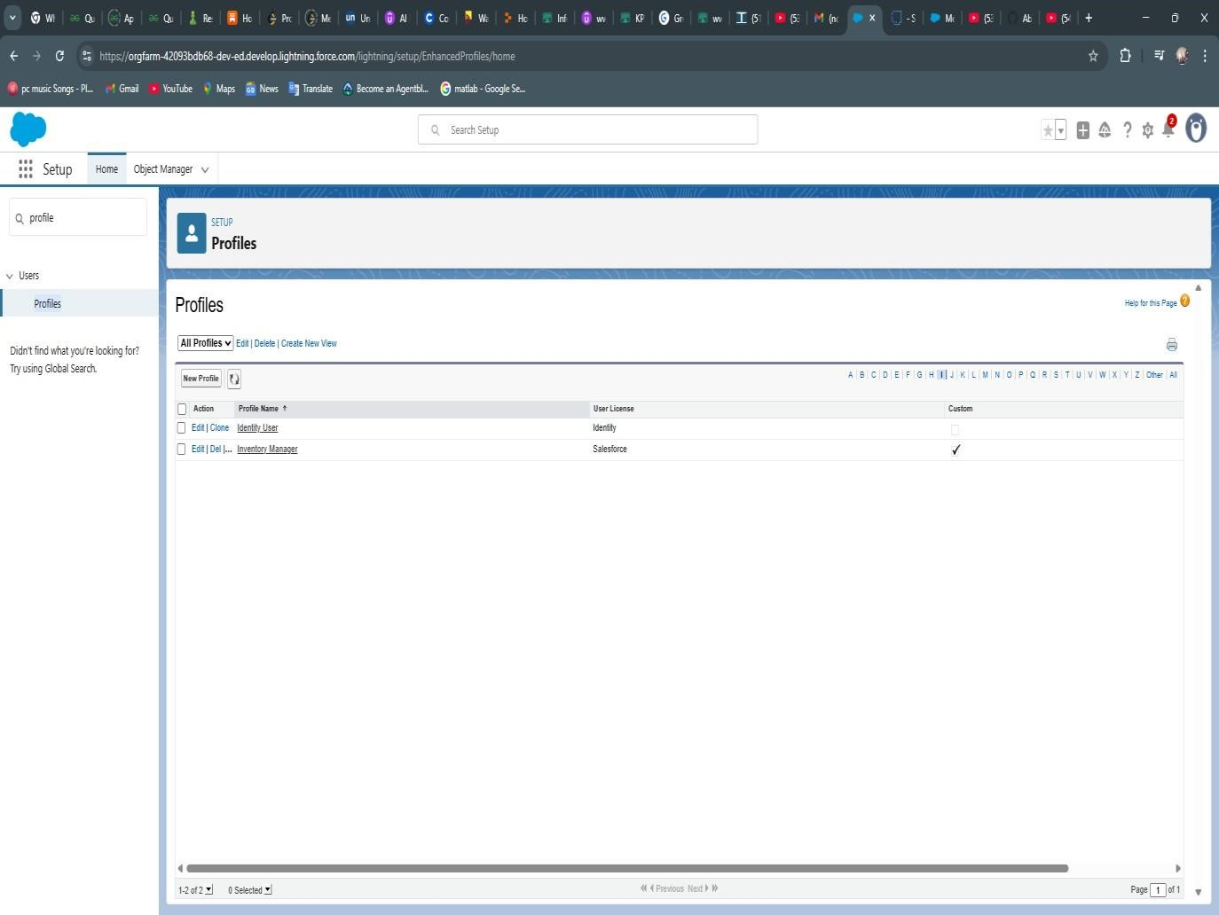

**Roles added to the Inventory Management:**

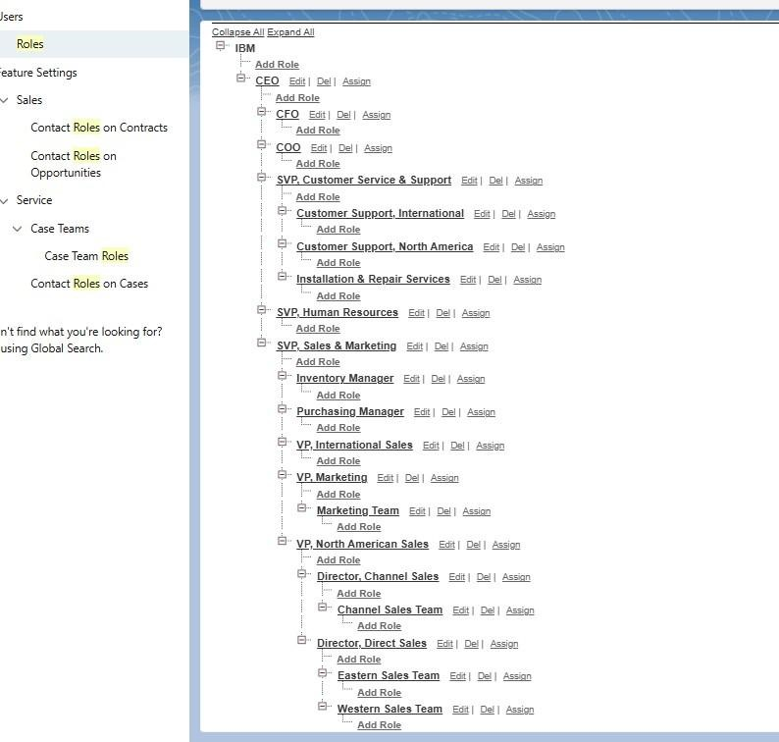

**Flows Actual Delivery Date:**

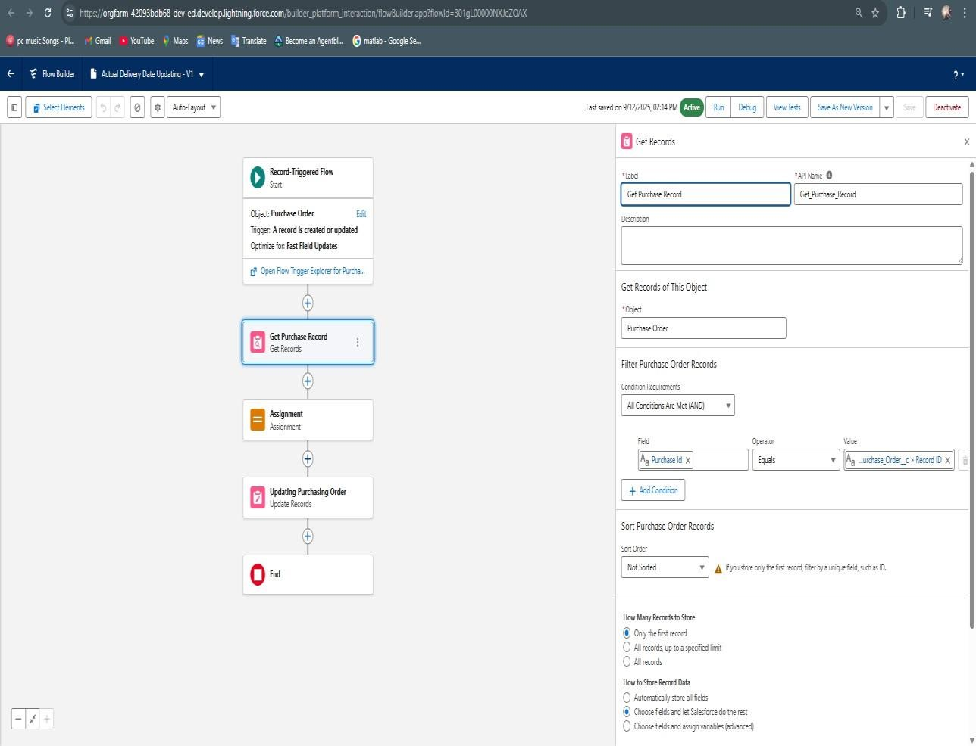

**Triggers: CalculateTotalAmountTrigger :**

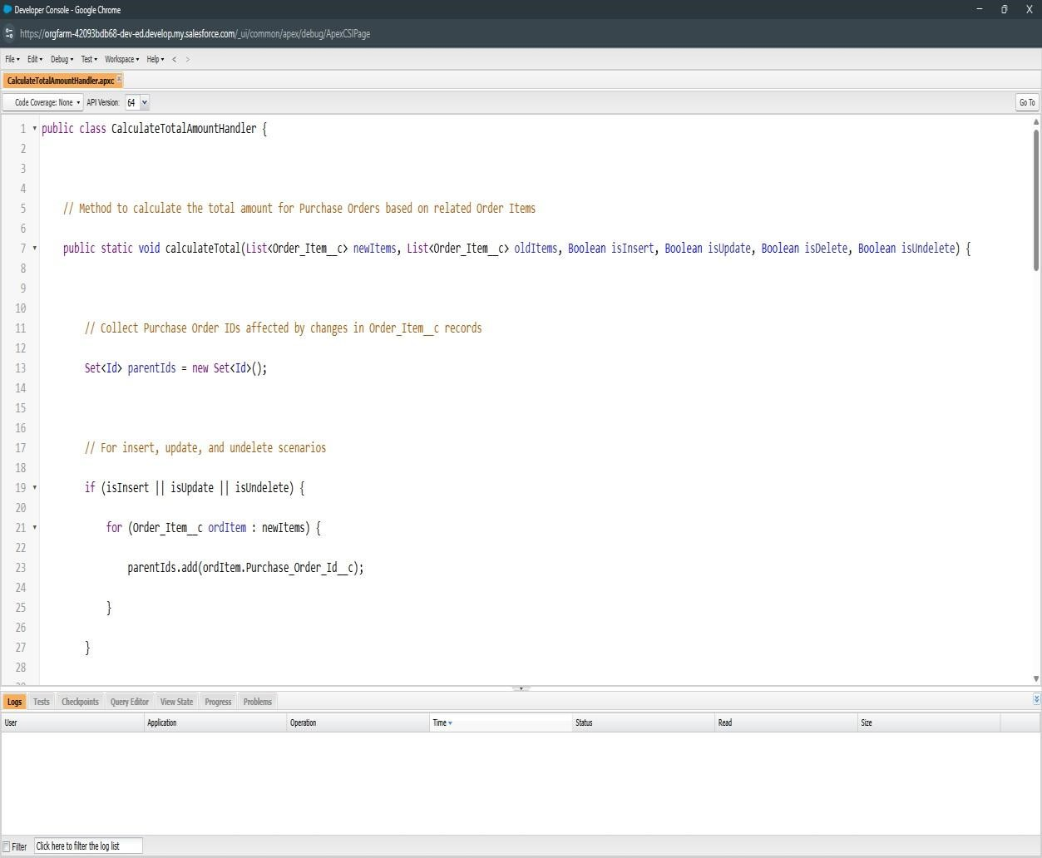

**CalculateTotalAmountHandler:**

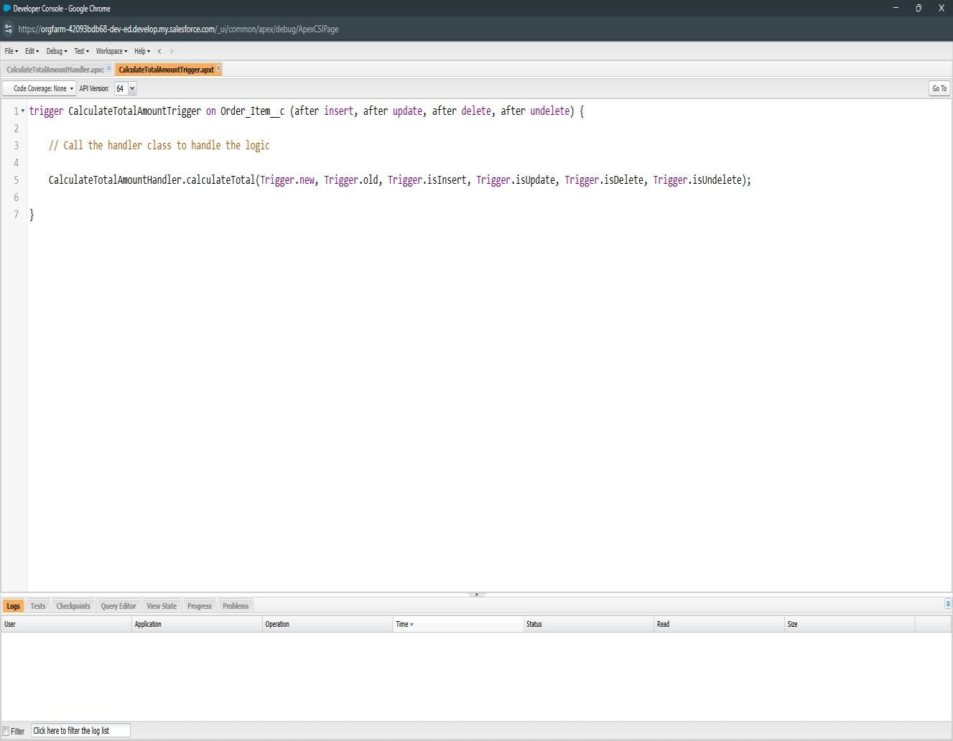

**Purchase order in the Medical Inventory Management app :**

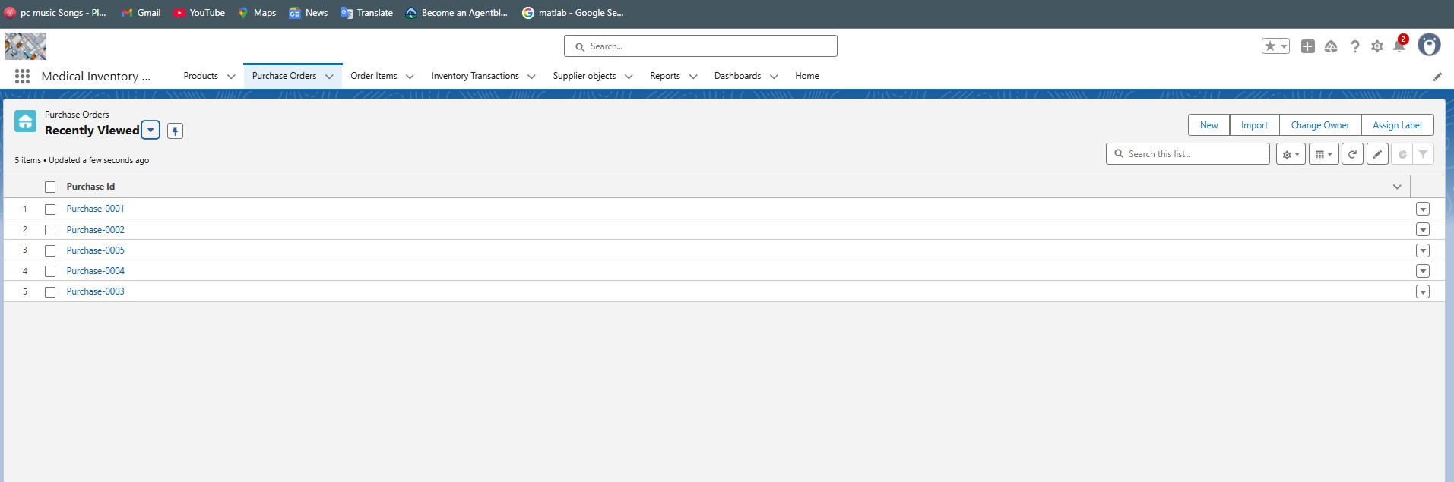

# Supplier objects Medical Inventory Management App

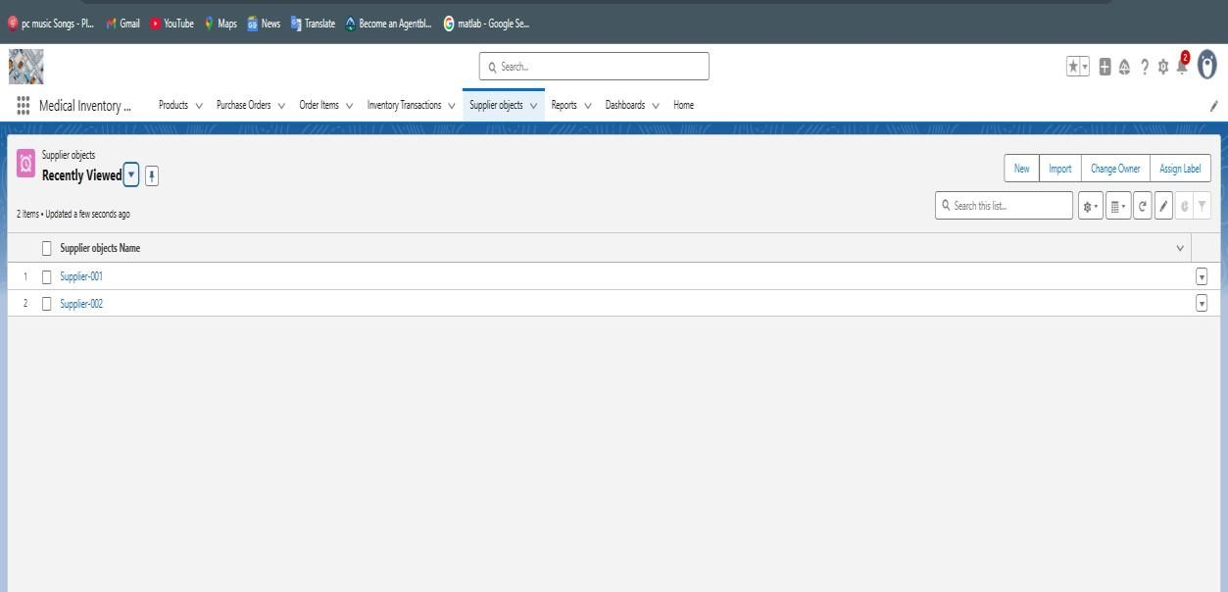

# Reports created in Medical Inventory Management App

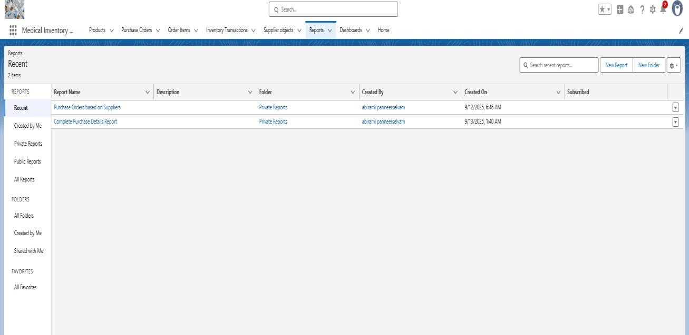

# Report: Purchase Orders based on Suppliers

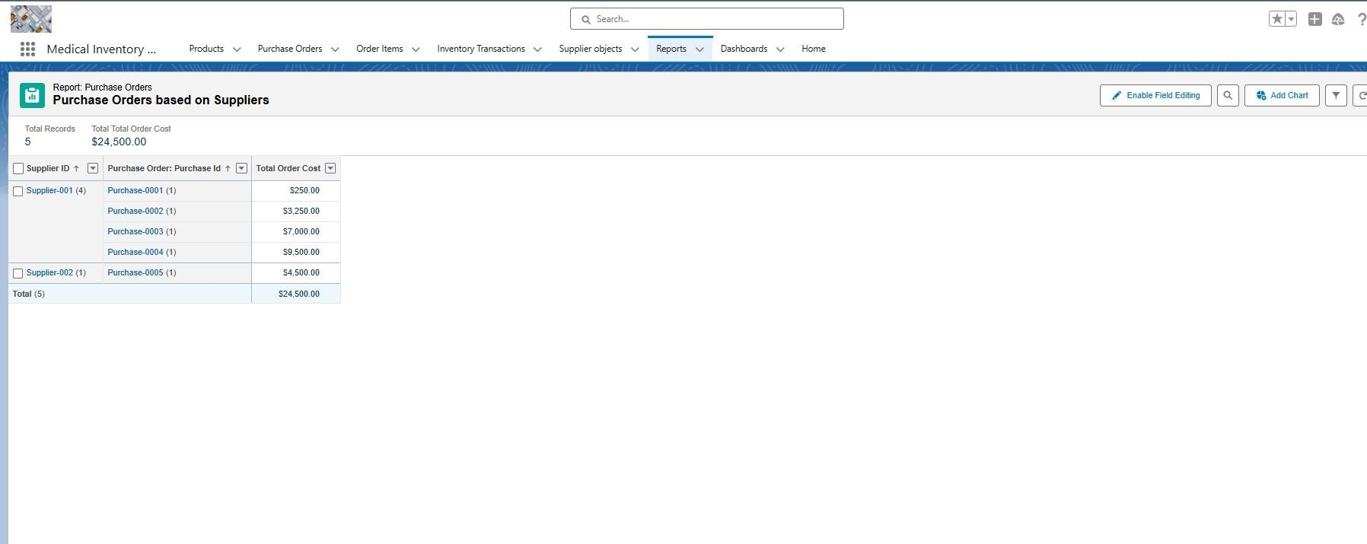

**Medical Inventory Dashboard:**

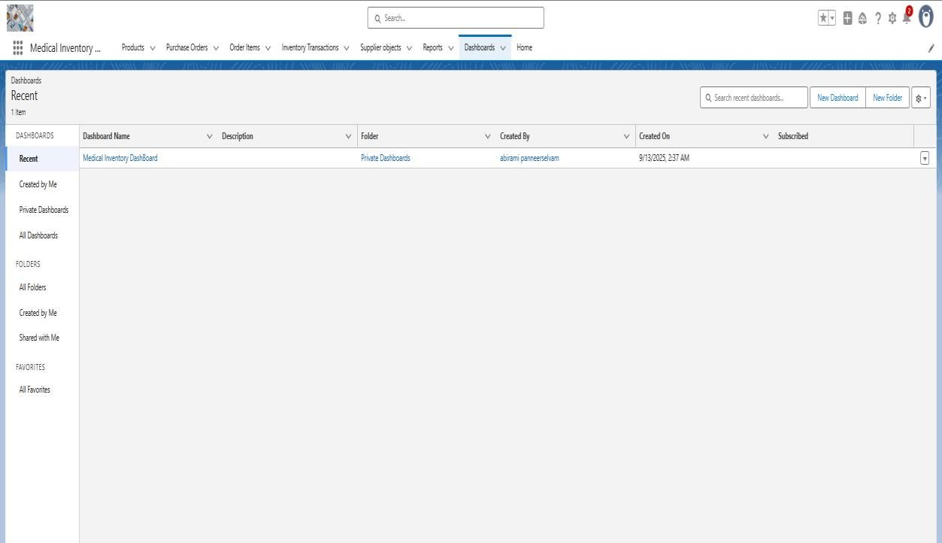

**Purchase Orders based on Suppliers dashboard:**

